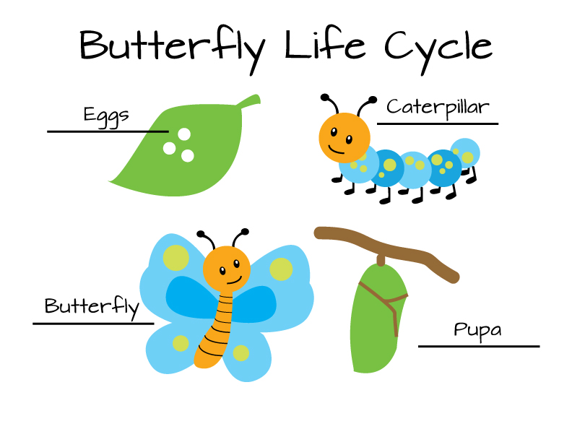

[This Photo](https://sageandzoo.com/2013/06/25/butterfly-life-cycle-download/) by Unknown Author is licensed under [CC BY-SA-NC](https://creativecommons.org/licenses/by-nc-sa/3.0/)

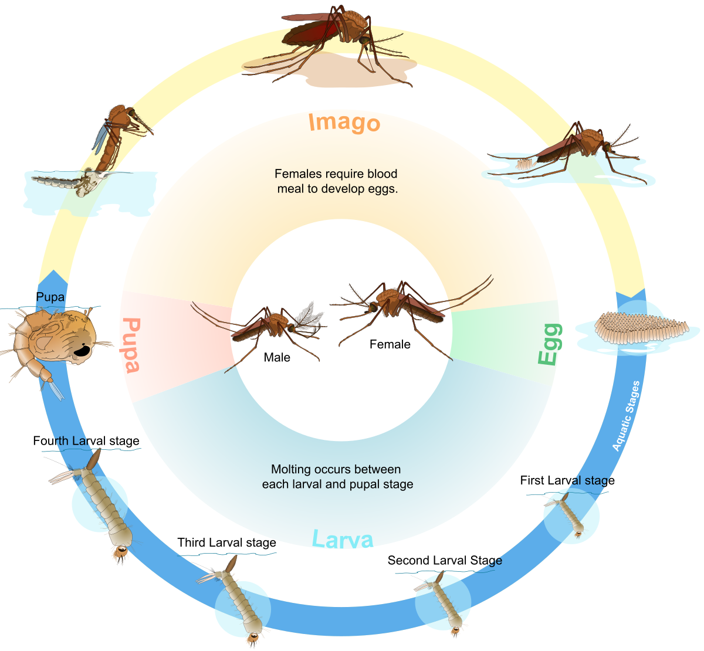

[This Photo](https://en.wikipedia.org/wiki/Biological_life_cycle) by Unknown Author is licensed under [CC BY-SA](https://creativecommons.org/licenses/by-sa/3.0/)

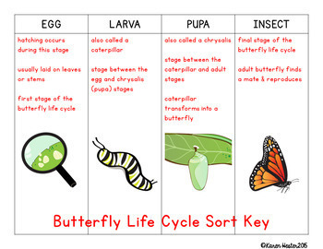

[This Photo](https://www.teacherspayteachers.com/Product/Life-Cycles-Science-Concept-Sorts-1946960) by Unknown Author is licensed under [CC BY-NC-ND](https://creativecommons.org/licenses/by-nc-nd/3.0/)

