EFFECTS OF DROUGHT ON SOIL IN NATURAL ENVIRONMENTS AND IMPACT ON BIODIVERSITY

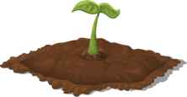
BECOMES SALTY
EROSION
TOXIC TO PLANTS
PLANTS DIE
UNHEALTHY SOIL
ANIMALS DIE
MICRO ORGANISMS DIE
HARMFUL TO ANIMALS
DUST
SOIL IS LOST

