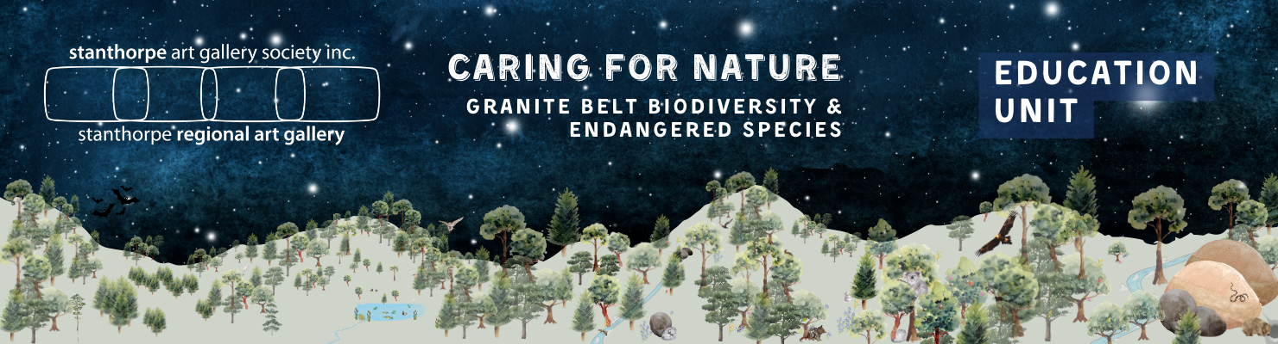

YEAR 1

UNIT SUMMARY

ENGLISH: Language and Literacy: Organisational Features of texts. Informative Texts - report, Recount, description, information books, Online texts.

SCIENCE: Biology: Needs of plants and animals. Growing plants

HASS: Geography: Natural, Managed and Constructed Features of local area.

ART: Dioramas; 2D works of art based on the themes of biodiversity, endangered animals of the Granite Belt for the Crisps” Art Show

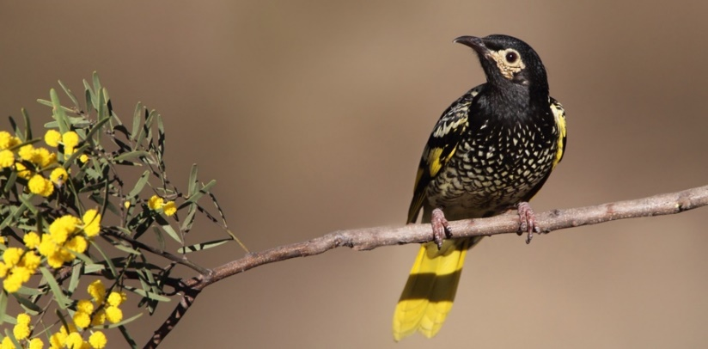
ASSESSMENT: Some activities in the unit have been considered as possible assessment tasks. A generic rubric has been created to cover the main CDs.

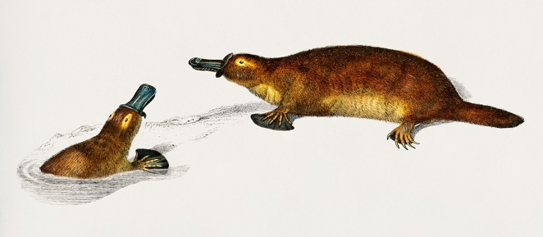
Note: Throughout the planning, “endangered” refers to vulnerable and endangered species of the granite belt. Lists of both are available here (animals) and here (plants).

Subject/Content Descriptions | Teaching and Learning | Resources and Vocabulary | Notes

ENGLISH
Language: Text Structure and organisation  Students explore how texts are organised according to their purpose, such as to recount, narrate, express opinion, inform, report and explain.  AC9E1LA03  Students understand how print and screen texts are organised using features such as page numbers, tables of content, headings and titles, navigation buttons, swipe screens, verbal commands, links and images.  AC9E1LA05 | Learning Focus 1  We are learning about different kinds of texts. We will think about the purpose of different texts.  Students have access to various texts about wombats. Texts include Wombat Stew Picture Book, Information books, poster, sign, opinion, recount, procedure. After browsing, ask the children why a picture Book about wombats looks different from an information book about wombats. Lead the students to understand that they each have a different purpose, and what that purpose is.  If required, give students and elicit from them examples that describe “purpose” in everyday life  A PowerPoint is included for exploring and discussing the last 4 texts.  Using a table or other graphic organiser, students work in pairs or Learning Teams to record the features of the text types reviewed. This activity could also be a whole class task. | Familiar Picture Books and age-appropriate information books about wombats  PowerPoint: Wombats  https://www.youtube.com/watch?v=8Z6MapiRNWY  Reading of Wombat Stew if no access to the book.  Definition of Purpose:  Purpose is the reason why something exists or is done. It's like why you go to school or why you eat breakfast. It's the thing that you want to achieve or accomplish. For example, a toy's purpose is to be played with, and a pencil's purpose is to write with. It's like a special job or mission that something or someone has.  Vocabulary:  narrative; fiction; information; description; recount; procedure; sign; poster; audience; purpose; facts | The first two learning activities in the Prep Unit, compare Fiction and Information texts and introduce the features of Information texts.  Do these prior to the unit if your students require some revision.
 | Learning Focus 2  We are exploring features of texts that organise and help to identify the purpose.  Features of Informative Texts (books)  Students work in small groups or pairs with at least one information text. As you find each feature in your book (or Big Book), have them identify the same feature in their books. Discuss the purpose of each feature. How does the feature help the reader to find information and to learn?  Table of Contents (or Contents) directs the reader to a specific chapter  Chapter Title tells what information can be found there  Headings break down the information under a topic  Subheadings are located under headings and break down the topic even more  Text Box groups extra interesting facts  Glossary gives the meaning of new vocabulary  Index directs the reader to a specific fact or topic wherever it appears in the book.  Diagrams present the information in a pictorial way and are sometimes labelled.  Photographs are real images of the person, animal, object, place.  Captions describe a photograph or diagram.  Play a What Am I? game to reinforce learning e.g.  I am found in the back of an information book.  I help the reader to understand new words.  What Am I?  Model then let the students play as a whole class or in pairs. | Resources: Animal informative texts that contain some or all of the main features of Table of Contents; Chapters; Headings; Glossary; Index; text boxes; diagrams; photographs.  Alternatively, you could use age-appropriate information books on a range of subjects.  Vocabulary  Table of Contents; Chapter; Headings; Glossary; Index; text box; diagram; caption; heading; subheading
 | Learning Focus 3  We are exploring features of online texts that organise and help to identify the purpose.  Students log on to the National Geographic Kids link. Give a few minutes for browsing and then spend some time navigating the site in more structured way to find out how it is organised.  Discuss the purpose of the site. Discuss the organisation of the information: How is the information set out on the screen? How is this helpful? What about the colours? Headings? What information do the photographs give us? Who would be the audience for this website? How could this page be better? (Audio/ read back support; more photographs; etc)  Have a class discussion about the way the information is set out in a book and the way it is set out on the web page. What is different?  How do you find information in a book (Contents page, Index and use page number. Look under headings.).  How do you find information in the web page. (Scroll; click on hot spots; key word in the Search bar, click on a link, navigation buttons, etc).  Share opinions - which is easier to use? Which is better?  When would an information book be better than a website?  When would an information website be better than a book?  Repeat this approach with different books and websites as required. | https://www.natgeokids.com/au/discover/animals/general-animals/facts-about-wombats/  National Geographic Kids website - facts about wombats  Vocabulary:  navigate; hot spots; links; headings; website; web page; navigate; images | Online encyclopaedia e.g. WorldBook Online, or any appropriate information based site, can replace the geokids option.

SCIENCE
Science Understanding: Biological Sciences  Students identify the basic needs of plants and animals, including air, water, food or shelter, and describe how the places they live meet those needs  AC9S1U01  Students make and record observations, including informal measurements, using digital tools as appropriate  AC9S1I03 | Learning Focus 1  We identify the needs of plants by discussing how we care for plants at home.  Caring for plants at home.  Have a class discussion about firstly the plants at your home that are important or special (vegie garden, trees, flower garden, fruit trees, grape vines, farm crops, indoor plants etc.) The children can also share in pairs/learning teams.  Collect Data  How can we put all this great information together so that we can find out how many plants are special to us and our families, and which ones they are?  Have children come up with ideas such as Count and Tally; Make a table; Make a list; Make a graph/picture graph.  Choose 1 to compile as a whole class. | Resources: A few plants in pots for reference and to be cared for by the students.
 | Learning Focus 2  We explore why caring for plants and animals is important.  Why are they special?  How does your family care for them?  What do you do to help care for them?  Take special note of examples of protection from weather such as netting, shade cloth, greenhouse etc. as these can be incorporated into later Learning Activities.  Why do we do all these things? Students identify plants’ basic needs. (In order to live and be healthy plants need water, sunlight, air, good soil, protection from bad weather.)  Repeat Activities 1 and 2, using pets and other animals at home OR  Choose one or the other - plants or animals | Can be played at time of choice in the unit.  Online Interactive Game: “Garden Detective” Students explore a garden for insects. They collect, learn about their features and needs, and return to their habitat.  https://www.scootle.edu.au/ec/viewing/L699/index.html# | Other possible activities  Create a pictorial comparison activity regarding external features of the students - whole class or in groups.
Science Inquiry: Questioning and Predicting  Students pose questions to explore observed simple patterns and relationships and make predictions based on experiences  AC9S1I01  Students make and record observations, including informal measurements, using digital tools as appropriate  AC9S1I03 | Learning Focus 3  We think of questions that will help us to explore a local place and find the answers.  Choose a place for exploration - maybe a school garden, or a spot on the creek bank. You could join with Preps and all go to the same spot, or go somewhere else.  Before the field trip, the children create a “mind map” and predict  - what animals and/or plants live in this location  - Where in this place would they meet their needs e.g., where would they shelter?  Encourage the students to pose questions about this place and write them up to be followed up after the field trip.  Children have a sheet that they fill out while on their field trip. They can work independently or with a partner or Learning Team.  To follow up, go through the questions and have the class answer them, using what they have learned. If there is a question that we cannot answer, what can we do? | Vocabulary: habitat; location; shelter; needs; predict; prediction; protect; feature; sketch.  Excursion data collection Sheet (Yr 1 No.1) Copy the page on both sides so that each student has 2 wildlife examples to record.

ENGLISH
English: Literacy Creating Texts  Create and reread to edit short written texts to report on a topic or recount a real event.  AC9E1LY06  Students identify the basic needs of plants and animals, including air, water, food or shelter, and describe how the places they live meet those needs | Learning Focus 1  We are learning how to write an information text (recount)  Revisit the features of a recount.  With modelling, guidance, etc jointly construct a recount of the field trip. Children add in their own plants/animals and how their need were met in this habitat e.g.  Yesterday our class walked down to Quart Pot Creek for a scientific investigation. We wanted to find out if the animals and plants had everything they need to survive. I spotted a .....duck..... it was... swimming..... It gets water and food from the creek . It eats insects and weed. It shelters in the weeds and grasses at the bank.  Along with the recount students make a final sketch on which they add the location of their plants/animals, location of food, shelter, water  Learning Activity  For further consolidation watch https://www.youtube.com/watch?v=TkCq54_ho-A  Australian Animals. It shows each animal interacting in its habitat - seeking shelter, finding food, etc. It is about 13 mins long so best over a few sessions with discussion after. Students can write some facts that they saw and heard in their activity book. | Students’ Science/Writing books | You could have the introduction sentences already written and students paste into their books. Then they add their data.

MATHEMATICS
Mathematics  Strand: Statistics  Students learn to:  acquire and record data for categorical variables in various ways including using digital tools, objects, images, drawings, lists, tally marks and symbols  AC9M1ST01  Students identify the basic needs of plants and animals, including air, water, food or shelter, and describe how the places they live meet those needs (cont.) | Other learning activities:  - Using a table or other graphic organiser, record of all plants and animals seen on the field trip and how and where their needs were met in this habitat. Use digital tools such as a table or other organiser in Word, if the children are ready for this.  - In Learning Teams, students care for a potted plant and record its growth. Each student in the team is responsible for the health of the plant and takes part in the recording of information in the group’s “Plant Growth Record” booklet.  Assessment or follow up Activity | Plant Growth Record

SCIENCE
Science Understanding: Earth and Space Sciences  Students describe daily and seasonal changes in the environment and explore how these changes affect everyday life.  AC9S1U02  Students make and record observations, including informal measurements, using digital tools as appropriate  AC9S1I03  Students describe how people use science in their daily lives, including patterns to make scientific predictions  AC9S1H01 | Learning Focus 1  We describe weather and climate changes in our local area and explore how they affect the animals and plants in this area.  NOTE: In order to understand the unique weather patterns and seasonal changes of the Granite Belt region when compared to the rest of the state, this could be a long-term data gathering and learning project.  As data is gathered or as the weather and seasonal patterns are discussed, and described, explore how they affect our plants and animals. The students will also most likely have personal experiences to share.  Ideas: Have the students pose questions for investigating before using these suggestions.  We observe leaves changing colour.  - Gather some autumnal colours for collage work or a class display.  - Sketch or photograph the seasonal changes to a deciduous tree in the school grounds or close by.  - Discuss ways in which we can sustainably use the fallen leaves and try them out.  - Find out why some trees lose their leaves and what happens to them during winter.  Reptiles hibernate.  - Research - what does hibernate mean?  - Why do only some animals hibernate?  - When do they begin to hibernate?  - Sometimes on the Granite Belt it gets warm and then gets cold again. How does this affect hibernating animals?  There are frosts  - What is a frost?  - What causes a frost?  - How do frosts affect our plants?  - How do frosts affect what we decide to grow?  - How are frosts a good thing for some of our plants?  - How do we protect plants from frost?  Rain and dry weather  - Record rainy days  - In which season/month did we get the most rain?  - What happens when it rains too much?  - What happens when it doesn’t rain enough?  - Who has water tanks/dams at home? What do you do with the water in the tanks/dams? What do farmers do with it?  Research tropical plants/desert plants and compare their external features to cold climate plants. | Gather natural resources throughout.  Autumn leaves, plants affected by cold or frost (basil is a good example).  Photographs/pictures of familiar natural places in Granite Belt area and particularly weather and seasonal changes.  Resources:  Invite a local farmer to talk to the class about how the seasonal changes affect what is grown and when and where it is planted.  What is done to protect the plants as they grow?  What do farmers do when they predict that rain or frost is coming?  Which farm animals do best during winter and how are they sheltered when it is very cold or very hot?  Invite a nursery worker (or visit a local nursery) to identify and discuss cold climate plants that grow well in the granite belt gardens. How are they cared for in the nursery?

HASS
Geography  Students identify the natural, managed and constructed features of local places, and their location  AC9HS1K03  Students collect, sort and record information and data from observations and from provided sources.  AC9HS1S02 | Learning Focus 1  We are learning the difference between natural, managed and constructed features of our local area.  This can be incorporated into the Science field trip or treated separately.  Watch the video that explains natural, constructed and managed places with follow up discussion and consolidation - finding pictures of each type and making classroom posters, drawing examples, etc.  Take a walk anywhere in the school grounds. Assist the students in identifying natural (plants, trees, grasses, rocks, soil etc) managed (mown grass, cleared areas) and constructed (seating, playground, paths) features of a particular area.  Ensure that the students understand the differences between the three categories.  Hand out an outline map of the area (that you have prepared earlier) and together sketch in and label the main features as natural, managed and constructed. The children can work independently or in pairs.  Before going on the field trip, have children predict what natural, managed and constructed features they expect to see. Make a list which is then further discussed after the field trip. When they sketch out the area on the field trip, they can also label examples of each kind of feature. | https://www.youtube.com/watch?v=UQNkpExlBlU  Natural, Managed, Constructed places

ENGLISH
English: Literacy Creating Texts  Create and reread to edit short written texts to report on a topic or recount a real event.  AC9E1LY06 | Learning Focus 1  We are using our understanding of reports and recounts to create, edit and read texts.  Prior to the visit of Queenie the Quoll, have the children research quolls or work through some information on quolls together.  Students formulate questions to ask Queenie. If they do not get a chance to ask their question, it will be discussed in class.  After Queenie’s visit children write an information report based on the content of Queenie’s visit. Their report will be factual - an informative text. They also include information they learned prior to the visit. It may be jointly constructed as a whole class effort, or scaffolded with a template that includes headings, room for illustrations etc. The report will also include the needs of quolls on the granite belt and a sketch of the habitat in which their needs are being met.  Each school will be given an ambassador, an endangered (toy) animal beautifully handmade locally.  When it arrives, have students prepare questions they would like to research about this animal and its habitat, , including why it is endangered.  Arrange for the students to research and answer - for example, the questions can be collected into a Question Box. Students in pairs or Learning Teams can draw one out and proceed to research and write a report that answers the question. Reports can be edited, typed up and displayed. The facts could also be collated under headings.  Other ideas:  Students could write a blog or diary about their ambassador, as if written by the animal itself. I am sure this little creature will have many adventures in and out of the Yr 1 classroom, that need to be recorded!  With the students, make a display of the basic needs of your ambassador that will enable them to live in the wild - actual samples, paintings, dioramas (see below), etc | I am not sure if visits are being arranged at this stage, so this is just-in-case.

VISUAL ARTS
Students use play, imagination, arts knowledge, processes and/or skills to discover possibilities and develop ideas  AC9AVAFD01  Students create arts works that communicate ideas  AC9AVAFC01 | Students use their knowledge of the needs of animals to create a diorama of a native animal in its natural habitat. You can limit their choices. Select 1 or more to focus on or allow students to choose, with the condition that the animal is native to Australia and if native to the granite belt region, even better.  Some examples of the latter include koala, spotted-tail quoll, thick tailed gecko, platypus, tusked frog, New England tree frog, swift parrot, regent honeyeater, all of which are endangered.  kangaroo, wallaby, kookaburra, cockatoo,  A simpler alternative is a drawing or painting of the animal in its habitat.  Have the children label the elements in the habitat that meets the animals needs - water, food, shelter.  In pairs (can be videoed) student take the role of their animal and share with their partner some facts about the basic needs of their plant or animal. e.g., Hi! I am a koala and I live in eucalypt trees in Girraween National Park. The eucalypt trees shelter and protect me because I climb high up into them. They also provide my food which is gum leaves. I stay close to trees near the creek so I can drink the water. It can be a simple or as comprehensive as you wish for your students.  This can be used as an assessment piece. | There are a good number of short YouTube videos that provide ideas and procedures for dioramas. Here are a few examples  Making a habitat diorama  https://www.youtube.com/watch?v=N_6MyTSbzZg  Start at 4m 5s Just over 210 mins long  Watch it for yourself and/or watch with the students  Diorama project  https://www.youtube.com/watch?v=FPiRfCbZx8k  6m 27s | Any 2D artwork related to the Crisps Art Show theme of biodiversity may be entered.  Therefore, the dioramas won’t qualify, but students could replicate as 2D paintings.

