THE REGENT HONEYEATER Factsheet
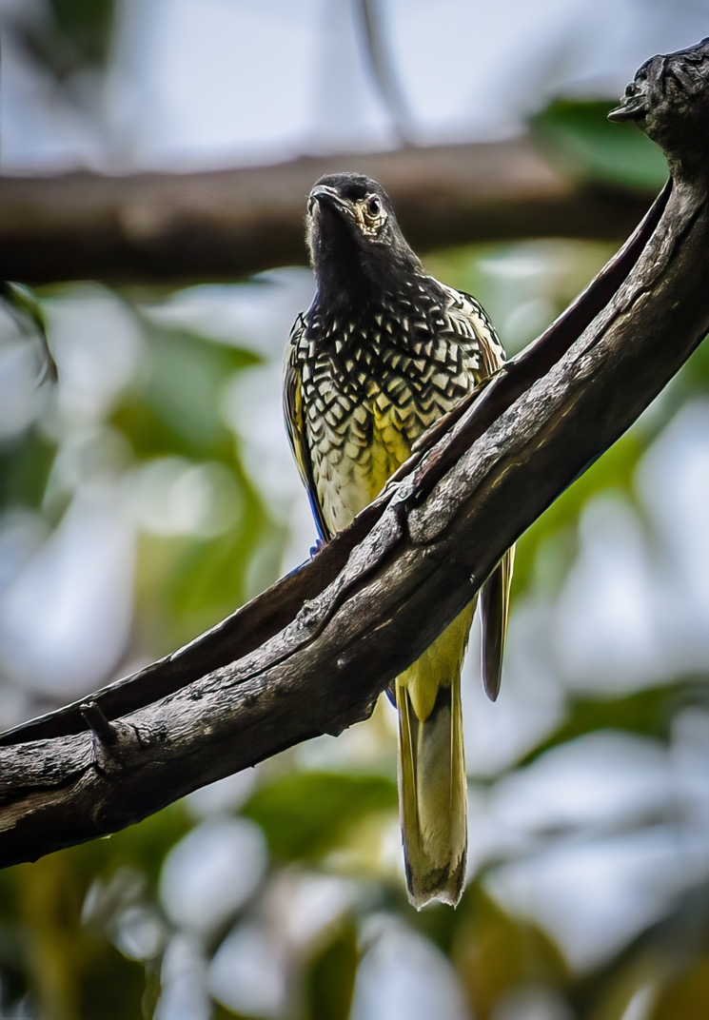
The Regent Honeyeater is critically endangered, not only in the Granite Belt region, but Australia wide. It is a flagship threatened woodland bird whose conservation will benefit many other threatened or declining woodland species.

DESCRIPTION:
- striking and distinctive, medium-sized, black and yellow honeyeater
- sturdy, curved bill.
- Adults weigh 35 - 50 grams,
- 20 - 24 cm long
- wingspan of 30 cm
- head, neck, throat, upper breast and bill are black, and the back and lower breast are pale lemon in colour with a black scalloped pattern.
- flight and tail feathers are edged with bright yellow.
- characteristic patch of dark pink or cream-coloured facial-skin around the eye.
- males are larger, darker and have larger patch of bare facial-skin.
- call is a soft metallic bell-like song
- Lives to 10 years in the wild
Regent Honeyeater Warren Bennett photographer Used with permission.
LOCATION:
- mainly inhabits temperate woodlands and open forests of the inland slopes of south-east Australia.
- Dry Box Ironbark open-forest and woodland areas inland of the Great Dividing Range
- Uncommon now in QLD
- only three known key breeding regions remaining: north-east Victoria (Chiltern-Albury), and in NSW at Capertee Valley and the Bundarra-Barraba region.
- its range has contracted dramatically in the last 30 years to between north-eastern Victoria and south-eastern Queensland.
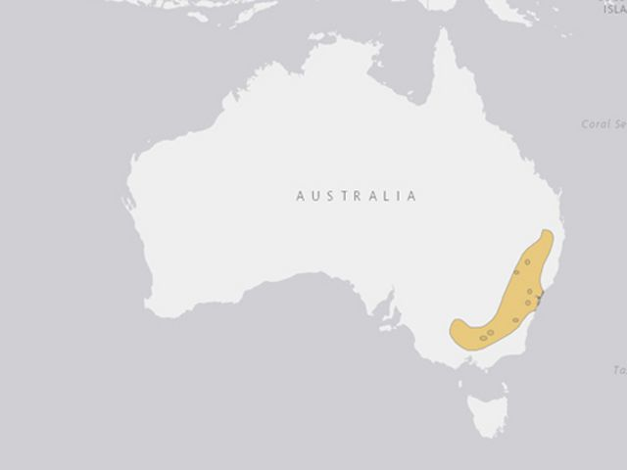
BEHAVIOUR:
- very active and requires an energy-rich diet to survive and breed successfully.
- social but are also often seen singly or in pairs.
- Larger groups tend to form around good food sources.
- Flocks of 50 to 100 were regularly reported in the early years of the 20th century; these are now rare.

HABITAT:
- found in dry, open eucalypt forests and woodlands, particularly in blossoming trees and mistletoe.
- Can occasionally be spotted in orchards and urban gardens.
- Key eucalypt species include Mugga Ironbark, Yellow Box, White Box and Swamp Mahogany.
- To successfully manage the recovery of this species a full understanding of the habitats used in the non-breeding season is critical.
FOOD:
- Omnivores
- foragers, although it feeds mainly on the nectar from a relatively small number of eucalypts that produce high volumes of nectar - Mulga Ironbark, White Box and Yellow Box.
- When nectar is scarce lerp and honeydew can comprise a large proportion of the diet.
- Will also eat nectar and fruit from the mistletoes
- Insects make up about 15% of the total diet and are important components of the diet of nestlings.
- feed on lerp (a small bug that lives on gum leaves)

BREEDING and YOUNG:
- Breeding is normally in the spring: mostly from August to October
- open cup-shaped nest is constructed of bark, grass, twigs and wool by the female
- usually nest in horizontal branches or forks in tall mature eucalypts and Sheoaks.
- Also nest in mistletoe haustoria.
- Lays two to three reddish-buff coloured eggs.
- They may have speckled purple-red and violet-grey markings.
- Eggs hatch after 14 days

THREATS
- Historical loss, fragmentation and degradation of habitat from clearing for agricultural and residential development.
- Continuing loss of key habitat tree species and remnant woodlands from major developments (mining and agricultural), timber gathering and residential developments.
- Overgrazing has decreased the ability of understorey vegetation to regenerate.
- Competition from larger aggressive honeyeaters, particularly noisy miners, noisy friarbirds and red wattlebirds.
- The small population size and restricted habitat availability make the species highly vulnerable to extinction because of loss of genetic diversity, and reduced ability to compete, increased predation and reduced fledging rates.
- Egg and nest predation by native birds and mammals.
- Inappropriate forestry management practices that remove large mature resource-abundant trees. Firewood collection and harvesting in Box-Ironbark woodlands can also remove important habitat components.
- Disturbance at nesting sites leading to reduced nesting success by recreational users.
- Loss of key foraging resources as a result of inappropriate fire regimes.
- Drought has limited the availability of free-standing water, which is considered a key component of an optimal nesting
- Due to depletion of numbers, males cannot readily learn their mating song, often mimicking other birds with no result. This is having a major impact on breeding.

ACTIVITIES TO ASSIST THE REGENT HONEYEATER
- Maintain a captive population of Regent Honeyeaters.
- Taronga Park Zoo has an excellent program which includes teaching the species’ song to the males via audio recordings, so that when released they will be able to breed.
- Provide landholders and other community members with information on the ecology and conservation requirements of the Regent Honeyeater.
- Use incentives on private land to encourage landholders to manage key areas.
- No loss of mature key nectar tree species. Minimise the removal of mistletoes at key sites.
- Encourage landholders/agistees to remove stock from sensitive riparian breeding sites.
- Protect and enhance key breeding and foraging habitats.
- Encourage natural regeneration and increase the remnant size of known and potential Regent Honeyeater habitats.
- Continue tree planting programs at key breeding and foraging locations.
- No further loss of known woodland and forest habitat throughout the range of the Regent Honeyeater from developments.
- Conduct research into habitat selection in non-breeding season and long-distance movements.
- Investigate impacts of interspecific competition for resources and nest predation by native birds.

A major component of the recovery effort is to implement a coordinated program of habitat protection and enhancement across the entire range of the species.
A captive breeding and release program commenced in 1995 with the intention of being able to reintroduce Regent Honeyeaters into suitable habitat with the view of reinvigorating depleted populations though natural breeding in the wild.

References:
https://www.environment.nsw.gov.au/threatenedspeciesapp/profile.aspx?id=10841
NSW Office of Environment and Heritage

https://www.swifft.net.au/cb_pages/sp_regent_honeyeater.php
State Wide Integrated Flora and Fauna Teams

Other References:
- Regent Honeyeater - Victorian Flora and Fauna Guarantee Action Statement No. 41
- Australian Government - Species Profiles and Threats Database, Regent Honeyeater
- Regent Honeyeater National Recovery Plan 1999 - 2003
- Higgins, P.J., Peter, J.M., & Steele, W.K. (Eds.) 2001. Handbook of Australian, New Zealand and Antarctic Birds, Volume 5, tyrant flycatchers to chats. Oxford University Press, Melbourne.
- Regent Honeyeater Captive Release - updates on SWIFFT
- Regent Honeyeater project
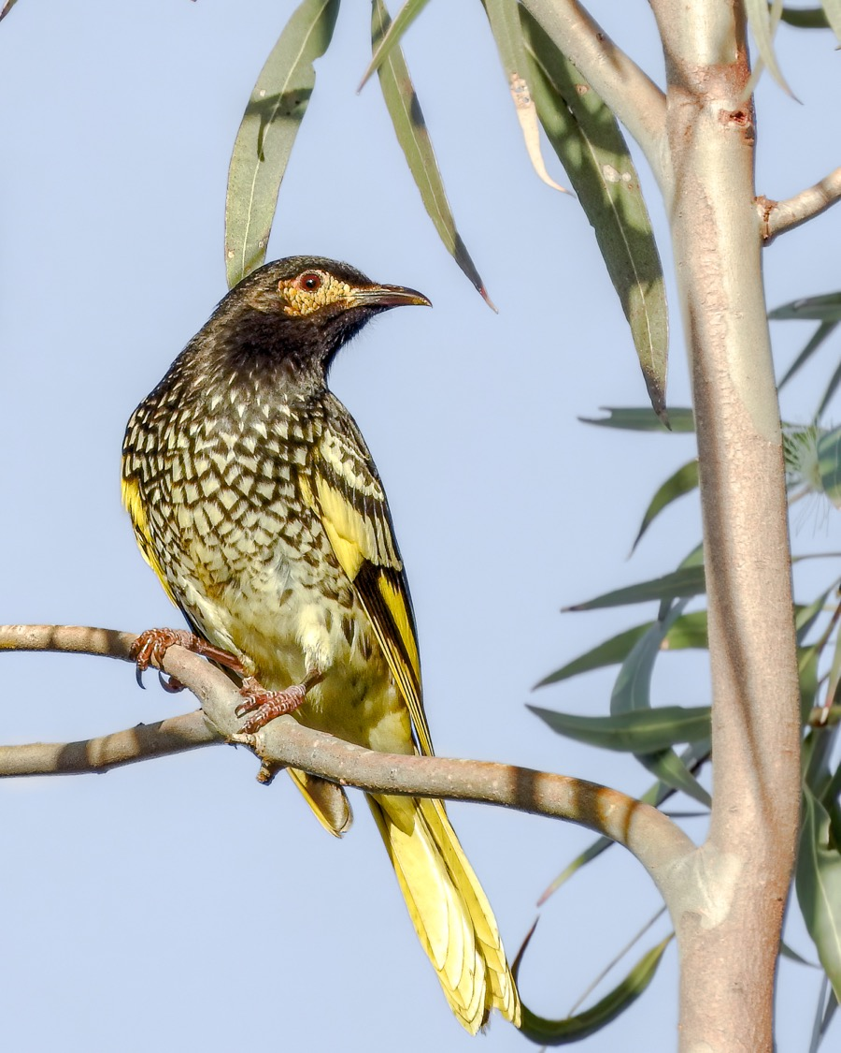
YouTube Videos
Saving the Regent Honeyeater NSW Office of Environment and Heritage4m 32s
Saving the Critically Endangered Honeyeater The Project: Regent Honeyeater Recovery 4m 28s
Regent Honeyeater Tim Norris photographer Used with permission.
Regent Honeyeater Tim Norris photographer Used with permission.

