THE BORDER THICK-TAILED GECKO Factsheet
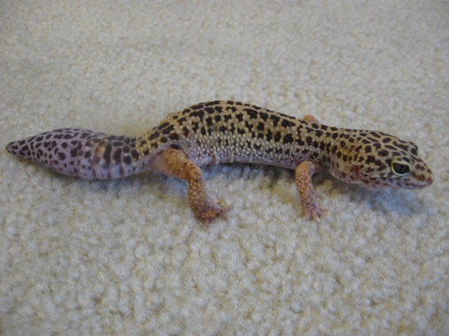
The Border Thick-tailed Gecko is a small lizard Found only on the tablelands and slopes of northern NSW and southern Queensland.

Conservation Status: Vulnerable

LOCATION:
- Most common in the granite country of the New England Tablelands.
- Occurs at sites ranging from 500 to 1100 m elevation.
- Populations are mostly fragmented, with over 50 discrete sites currently known that are separated by at least 2 km

DESCRIPTION:
- up to 10 cm long (average 7 cm)..
- fawn to brown above with faint darker brown flecks and many small white spots arranged in rows across the head, back and sides and on the legs
- looks 'knobbly' due to numerous conical tubercles, especially on the tail.
- tail is fat and rectangular with a thin tapering tip, and typically has four pale rings muscular build

BEHAVIOUR:
- active at night
- shelter by day under rock slabs, in or under logs, and under the bark of standing trees.

HABITAT:
- As implied by another of its common names (Granite Thick-tailed Gecko), this species often occurs on steep rocky or scree slopes, especially granite. Recent records from basalt and metasediment slopes and flats indicate its habitat selection is broader than formerly thought and may have extended into areas that were cleared for agriculture.
- Favours forest and woodland areas with boulders, rock slabs, fallen timber and deep leaf litter. Occupied sites often have a dense tree canopy that helps create a sparse understorey.
- These Geckos are active at night and shelter by day under rock slabs, in or under logs, and under the bark of standing trees.

FOOD:
- grazes on vegetation in their habitat
- grasses, foliage, bark and fruits of trees and shrubs

BREEDING and YOUNG:
- Dominant male breeds with multiple females
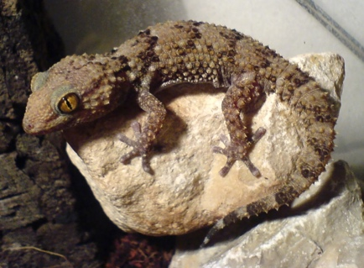
- Breed throughout the year
This Photo by Unknown Author is licensed under CC BY-SA
- Number of births peak between February and May.

THREATS
- Clearing and fragmentation of areas of rocky dry open forest and woodland for agriculture and development.
- Removal of bushrock.
- Frequent burning of rocky dry open forest or woodland.
- Removal of fallen timber for firewood.
- Grazing and trampling of habitat by domestic stock and feral goats.
- Predation by foxes and feral cats.
- Poor knowledge of species' distribution and population dynamics.
- Infestation by weeds, particularly coolatai grass and garden escapees.

National Recovery Plan for the Border thick-tailed gecko
This species is subject to threatening processes that generally act at the landscape scale (e.g. land clearing, bushrock and firewood collection and invasive weeds) rather than at distinct, defineable locations.

A targeted strategy for managing this species has been developed under the Saving Our Species program; click here for details. For more information on the Saving Our Species program click here

Ways of dealing with threats to landscape-managed species include:
- replanting or weeding as part of broadscale vegetation and habitat management programs
- controlling land clearing
- sharing water to sustain floodplain ecosystems
- managing coasts, estuaries and coastal wetlands
- managing national parks and reserves.

ACTIVITIES TO ASSIST THE BORDER THICK TAILED GECKO

- Retain bushrock in its natural setting and obtain rocks for gardens only from licensed dealers.
- Assist with the control of foxes, feral cats and feral goats.
- Protect areas of habitat from frequent fire.
- Limit firewood collection in areas of potential habitat.
- Retain and protect areas of rocky dry open forest and woodland from clearing, fragmentation and disturbance.

References:
https://www.environment.nsw.gov.au/threatenedspeciesapp/profile.aspx?id=10823

Other Resources:
https://www.aussieark.org.au/brush-tailed-rock-wallaby/?gclid=Cj0KCQiAutyfBhCMARIsAMgcRJRSlxFoUdJUJ87uyjerTlf116Ags5PqQYtDS03fmUDnU_b_5f1wlYoaArnzEALw_wcB
Aussie Ark Brush-tailed Rock Wallaby

https://www.rockwallaby.org.au/

