Description
The Swift Parrot is a slim, medium-sized parrot with a streamlined shape in flight, angular pointed wings and a long pointed purple-red tail.
The body is mostly bright green, with a dark blue patch on the crown. The forehead to throat is crimson and there is a crimson patch at the bend of the wing. The female is slightly duller, with a creamy underwing bar.
In flight, the bright green body, dark flight feathers and scarlet underwing coverts are prominent. They are noisy, active and showy, with a very fast, direct flight.

Location
Swift Parrots are migratory birds, endemic to south-eastern Australia. They breed in Tasmania and are found mainly in southern and central Victoria and eastern New South Wales in winter.

Habitat
Swift Parrots are found in dry sclerophyll forests and woodlands, suburban parks and gardens, and flowering fruit trees. In Tasmania, they are often among Tasmanian Blue Gum, Eucalyptus globulus.

Behaviour
Swift Parrots breed only in Tasmania and then fly across Bass Strait to forage on the flowering eucalypts in open box–ironbark forests of the Australian mainland. While on the mainland, they are nomadic, spending weeks or months at some sites and only a few hours at others, determined by the supply of nectar. They roost communally, often in the same tree each night. They are almost always in trees, coming to the ground only to drink.

Feeding
Swift Parrots feed in the outer canopy of flowering eucalypts, eating mainly nectar, as well as some psyllids and lerps, seeds, and flowers. They are active and agile when feeding, often hanging upside down.
At sites where food is abundant, Swift Parrots can congregate in large flocks and associate with smaller lorikeets and honeyeaters.
In dry years, when the eucalypts’ flowering is poor, Swift Parrots are forced to travel far and wide to find enough food. Some birds fly as far as coastal south-east Queensland, making the world’s longest known parrot migration.

Breeding
Swift Parrots breed only in eastern Tasmania – around October to December – to coincide with the flowering of the Tasmanian Blue Gum. They nest in tree hollows or the trunk, branch or spout of a living or dead gum. Many pairs breed close together and may return to the same nest site each year.
Breeding season is from September to April.

Alternative names
Red-faced Parrot, Red-shouldered Parrot, Swift or Swift-flying Lorikeet, Red-faced, Red-shouldered, Swift-flying Parakeet, Clink, Keet, Talking Keet

Risks to this species
Habitat destruction, Climate change, Domestic animals

Status
Critically endangered

Photography by Mick Roderick
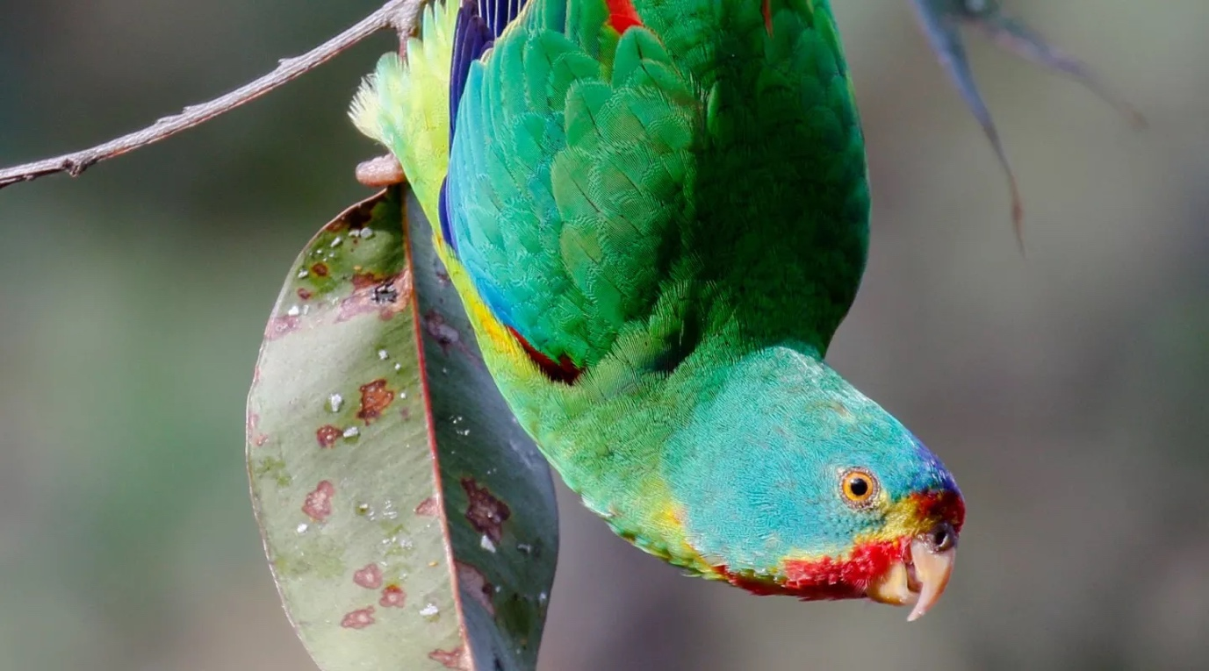
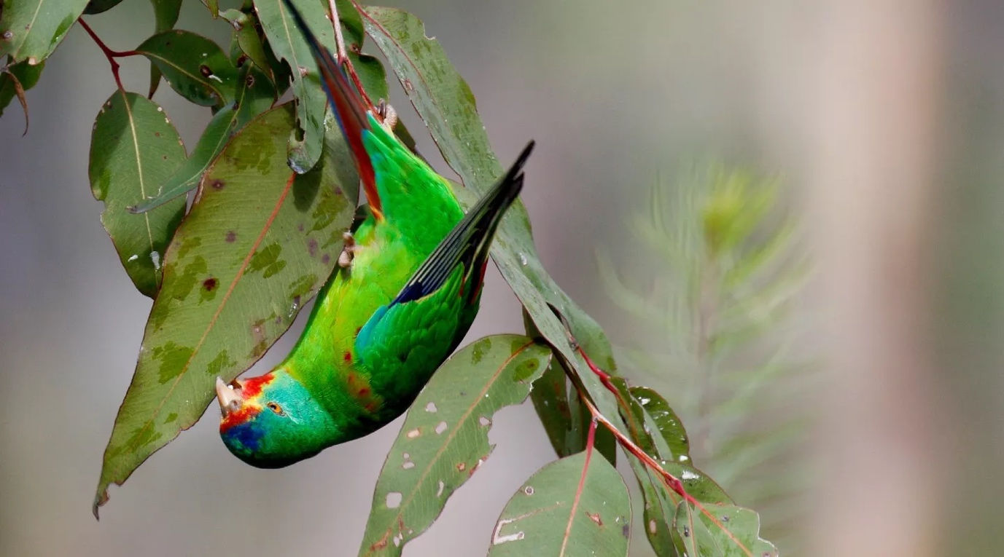
Photography by Mick Roderick
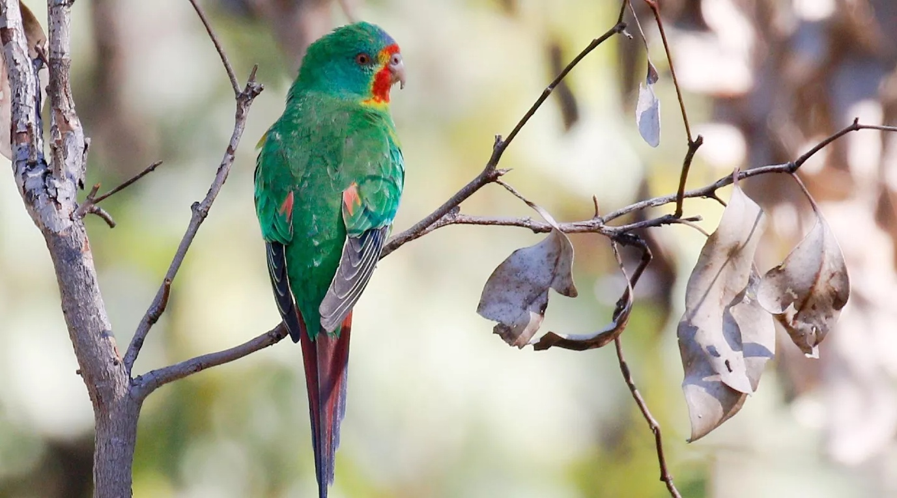

Photography by Mick Roderick

References:

Birdlife Australia website. https://birdlife.org.au/bird-profiles/swift-parrot/ Updated November 2022. Extracted 14.02.203

