THE SPOTTED-TAILED QUOLL Factsheet

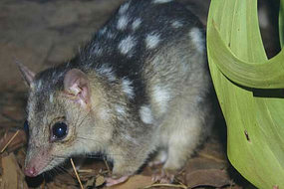
INTRO
Spotted-tailed quolls were once found all along the eastern Australian coastline, but they have disappeared from more than 90 percent of their range. They are an endangered species in this region.

LOCATION
They are now most common in Tasmania, or in the large forested national parks in eastern New South Wales.

DESCRIPTION
- cat-sized, carnivorous marsupial
- reddish-brown fur
- the largest member of the quoll group
- has distinctive white spots over its back and tail
- males are 380–759 mm in head and body length, and
- females are 350–450 mm.
- sometimes called the Tiger Quoll

HABITAT
- recorded across a range of habitat types, including rainforest, open forest, woodland, coastal heath and inland riparian forest,
- use hollow-bearing trees, fallen logs, other animal burrows, small caves rock outcrops as den sites.
- females occupy home ranges of 200-500 hectares,
- males occupy very large home ranges from 500 to over 4000 hectares.

BEHAVIOUR
- mostly nocturnal, although will hunt during the day
- spend most of the time on the ground, although also an excellent climber
- will hunt possums and gliders in tree hollows and prey on roosting birds.
- are known to traverse their home ranges along densely vegetated creek lines.
- communicate with one another using soft hisses and clicking sounds
- when threatened can let out a deafening screech that sounds like a circular saw.

FOOD
- a predator with a preference for medium-sized (500g-5kg) mammals.
- consumes a variety of prey, including gliders, possums, small wallabies, rats, birds, bandicoots, rabbits, reptiles and insects.
- also eats carrion and takes domestic fowl.

YOUNG AND BREEDING
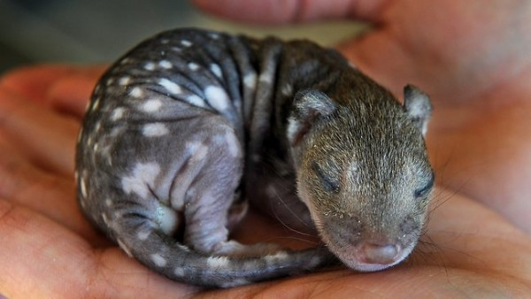
- generally breed during winter.
- being marsupials, quoll young (pups) spend the first part of their lives in a pouch.
- Average litter size is five
- both sexes mature at about one year of age.
- life expectancy in the wild is about 3-4 years.

THREATS
- habitat destruction,
- attacks from foxes, wild dogs,
- competition with foxes, wild dogs for food and habitat
- vehicle strike
- females and young can be poisoned by baits left for feral animals.

WHAT CAN BE DONE TO PROTECT THE SPOTTED-TAILED QUOLL

STEPPING STONES IN THE SOUTHERN DOWNS https://www.quollsa.org/spotted-tailed-quoll
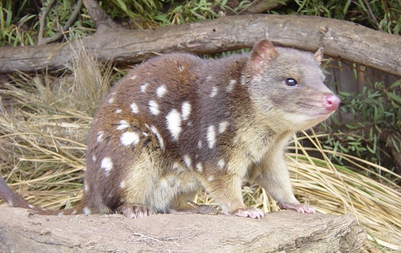
Tracking quolls in the Granite Belt
The Quoll Society is working with local landowners in the Granite Belt region to connect quolls with one another for breeding.

The Stepping Stones Project is planting corridors and stepping stones.

This will allow quolls to move more easily and safely across their environment.

The project will involve over 30 properties and will aim to plant more than 20,000 native trees and shrubs.

Contact us if you are a landholder in the Southern Downs local government areas, and want to be part of this amazing project.

This project received grant funding from the Australian Government’s Environment Restoration Fund.

SECRET LIVES OF QUOLLS

Tracking quoll movements in the Granite Belt
Despite their size and position as apex predators, we still know very little about what spotted-tailed quolls get up to after dark.
We are learning more by tracking the movements of quolls in and around Girraween National Park.
Using PVC traps, we capture quolls and fit them with a GPS collar before releasing them.

Collars are designed to fall off after three months, but if all goes well we will re-trap and retrieve the collars before that.
So far, the project has provided invaluable information on quoll movements, with four male quolls tracked for periods of four to eight weeks.

We have learnt that quolls will use farmland,but only where there is corridors or patches of remnant vegetation, while male quolls roam over home ranges up to 2500 hectares!
This project has been funded through two Queensland Community Sustainability Action grants.

JOINING THE DOTS
Mapping the distribution of the spotted-tailed quoll in South East Qld.
The Quoll Society was successful in applying for funding through the Queensland Government’s Community Sustainability Action Grants Program to map the current distribution of quolls in South East Queensland.

We'll be deploying camera traps across at least 36 national parks, state forests, local conservation areas, and private lands, to find out where quolls are surviving in Queensland. We will use the results of the study to create partnerships with government, community groups and private landholders to proactively conserve and increase remaining quoll populations, as well as restoring areas where quolls previously occurred but are now absent.
COUNTING SPOTS

Estimating population size and densities of spotted-tailed quolls in New South Wales national parks
Did you know that each quoll has an individual spot pattern that acts like a unique fingerprint?

QuollSA is using this method to identify and count spotted-tailed quolls in national parks near Tenterfield, NSW.

Camera traps collect thousands of images of quolls (and other animals) three to four times a year to assess changes in population sizes through seasons and from year to year.

The project aims to prove the feasibility of this technique, which will allow future quoll surveys to use camera traps instead of invasive and stressful live trapping.

REFERENCES
Bush Heritage Website

Quoll Proof Chicken Runs
The Quoll Society
NSW Government: Environment
Niquoll the Spotted-Tailed Quoll 1min 14s (YouTube)
Spotted-Tailed Quolls at Mulligan’s Flat 4m 17s (YouTube)

