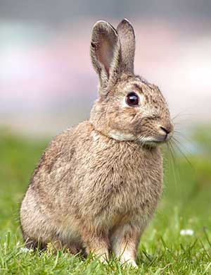
Introduced Animals - European Rabbit
The first rabbits, numbering just five, arrived in Australia with the First Fleet in 1788.
Initially, they were bred in confined enclosures for food and appear to have had no noticeable impact on the local environment.
Description:
- small mammal with long, muscular hind legs and shorter front legs.
- long upright ears,
European Rabbit
- large protruding eyes,
- soft, greyish-brown fur
- short fluffy tails
- adult rabbit weighs 0.8 to 2.3kg and is about 40 cm in length.
Behaviour:
- hop using a galloping gait, where the back paws land together forward and outside of the front paws.
Food:
- a hungry, greedy feeder,
- grazing on a variety of grasses and shrubs
- sometimes eats the entire plant, including the roots and seeds.
- may also strip the bark off trees and shrubs.
- Except in very dry conditions, the rabbit gets all the moisture it needs from its food.
Habitat:
- can be found in many different areas of Australia, ranging from deserts to coastal plains.
- Their distribution is only restricted by this their ability to find soils suitable for digging their underground in burrows.
- There are about 200 million rabbits in Australia today.
Breeding:
- In just 18 months, two rabbits can produce as many as 180 additional rabbits.
- A rabbit can live for up to 9 years.
Effects on wildlife and habitat
- their destructive behaviour on plants prevents the regeneration of vegetation.
- have been declared the number one pest in Australia because of the severe damage they are causing to the Australian ecosystem.
- overgraze the land to the point that native plants die, leading to the wide-scale extinction of native plants. They are the single most significant cause of the extinction of numerous native plants and animals
- The loss of native plants contribute to the decline and in some case the extinction of native animals such as the bilby and the bandicoot.
- Loss of vegetation results in soil erosion.
- Rabbits also eat pastures put down by farmers for their sheep and cattle flocks and drink from water supplies set aside for livestock.
- During droughts, when food is scarce, rabbits dig up and eat the roots and tubers of plants, thereby killing them.
- Rabbits threaten native burrowing animals, such as the bilby and the burrowing bettong, by evicting them from their burrows and moving in.

https://trishansoz.com/trishansoz/animals/rabbit-australian.html Retrieved February 2023

Resources: https://www.dcceew.gov.au/sites/default/files/documents/rabbit.pdf
Australian Government: Department of Sustainability, Environment, Water, Population and Communities

