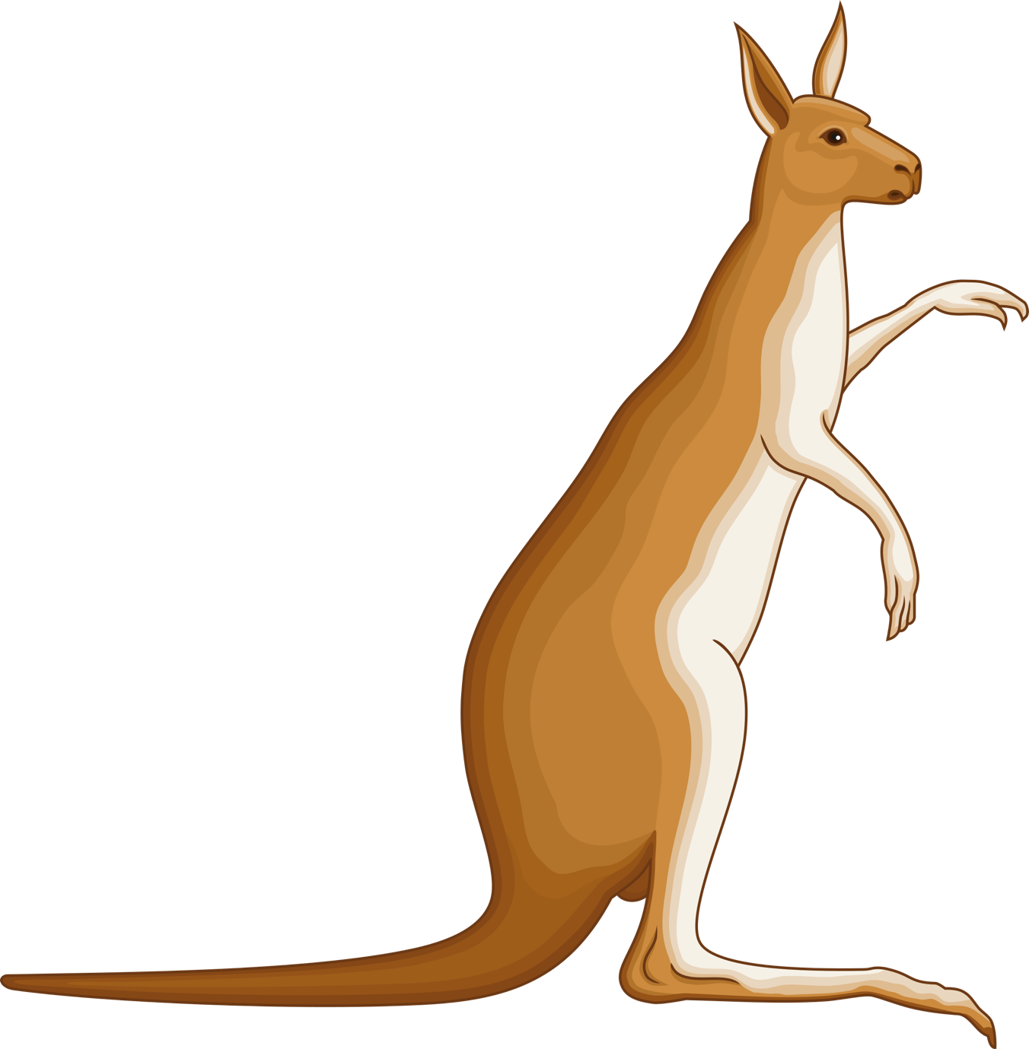
NAME: .................................................... EXTERNAL FEATURES
I am a
NOSE
FUR
FRONT PAWS PPAWS
EARS
TAIL

NAME: .................................................... EXTERNAL FEATURES
I am a
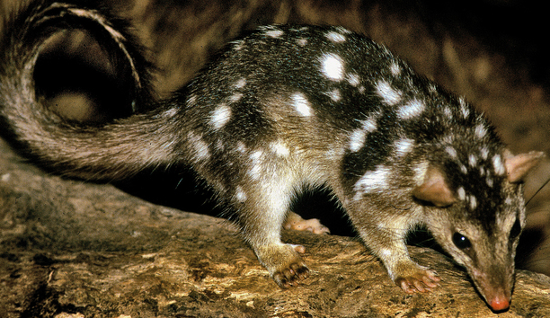
NOSE
FRONT PAWS PPAWS
FUR
EARS
TAIL
NAME: .................................................... EXTERNAL FEATURES
FUR
FRONT FOOT PPAWS
EARS
TAIL

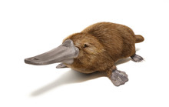
I am a
EYES
NOSE
NAME: .................................................... EXTERNAL FEATURES

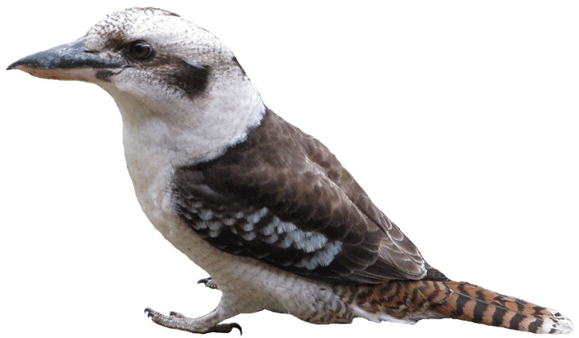
CLAWS
FEATHERS
EYES
TAIL
BEAK
WINGS
I am a

