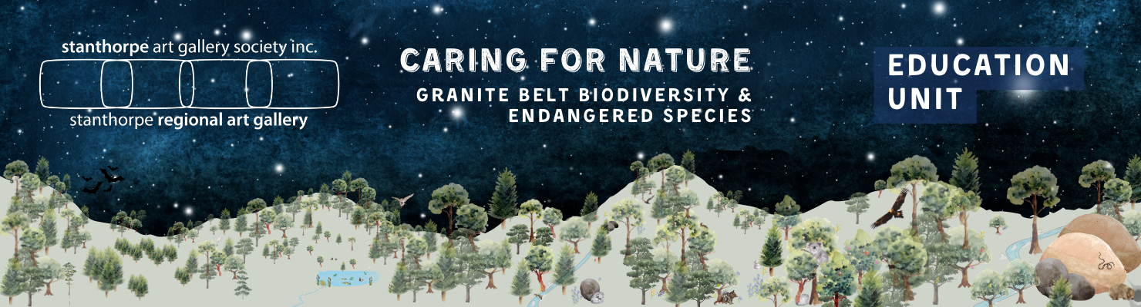

PREP

UNIT SUMMARY

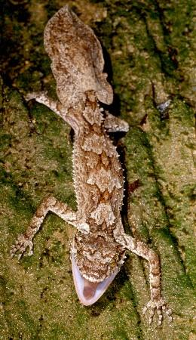
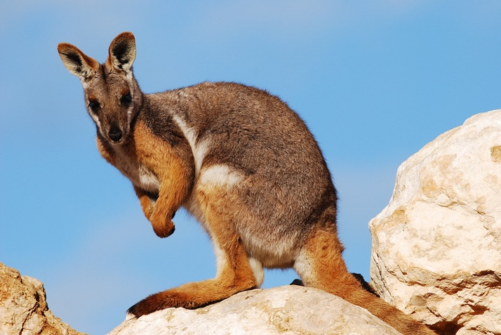
Figure 1 Brush tailed rock wallaby
ENGLISH: Language and Literacy: Different types of texts.

SCIENCE: External features of animals and plants

HASS: Features of familiar places and places they belong to, special places, places to be looked after.
Science/HaSS/ Field trip to pose questions, collect data and information, share findings.

ART: Puppets. 2D pictures of animals in the granite belt as per Crisps Art Show details.

ASSESSMENT: Some activities in the unit have been considered as possible assessment tasks. A generic rubric has been created to cover the main CDs.
Figure 2 Thick tailed gecko
Note: Throughout the planning, “endangered” refers to vulnerable and endangered species of the granite belt. Lists of both are available here (animals) and here (plants).

Subject/Content Descriptions | Teaching and Learning | Resources and Vocabulary | Notes

ENGLISH
Literacy:  Students identify some familiar texts, such as stories and information texts, and their purpose.  AC9EFLY01  Language: Text Structure and organisation  Students understand that texts can take many forms such as signs, books and digital texts  AC9EFLA03  Literacy:  Students identify some familiar texts, such as stories and information texts, and their purpose.  AC9EFLY01 (Cont)  Language: Text Structure and organisation  Students understand that texts can take many forms such as signs, books and digital texts  AC9EFLA03 (Cont)  Literacy:  Students identify some familiar texts, such as stories and information texts, and their purpose.  AC9EFLY01 (Cont)  Language: Text Structure and organisation  Students understand that texts can take many forms such as signs, books and digital texts  AC9EFLA03 (Cont) | Learning Focus 1  We are learning about different texts.  Allow time for the students to browse the mixed-up collection and to informally discuss the texts.  Explain that we are firstly only going to look at the front and back covers.  Each child chooses a book from the pile, or that can work with a partner.  Ask:  Why do books have covers? General discussion to elicit answers such as - to keep the pages together, to keep the pages clean, easier to hold; to protect the book.  Indicate on your book (or big book) the TITLE - what is the title (the name of the book; it tells you something about the book, etc.). Why is it on the front cover? Why is it in a large font?  Engage in discussion about other features of the front cover, such as the AUTHOR, ILLUSTRATOR, PICTURES, or PHOTOGRAPHS, etc.  If appropriate, introduce the BLURB on the back cover and any other features that children find on either the front or back cover.  Learning Focus 2  We are learning about Fiction and Non-Fiction texts and how they are different.  Revisit book covers in general, noting features such as title, author’s name, photographs, or illustrations, etc.  Choose a picture book about an animal e.g., elephant as well as an informative book about the same animal.  How are these 2 books the same? General discussion  How are these 2 books different? Discuss with a learning partner.  Share ideas.  If someone has identified that one is a story and the other a true book, ask  How do you know? How does the cover help you to know?  What should we do if we are not sure whether the book is made up or true? We open the books and look for clues.  What clues are we looking for?  Model the process of determining whether Fiction or Non-Fiction/ Informative. At this point you may introduce such features as photographs, text boxes as they arise.  At this point (or earlier) introduce the terminology of Fiction, Non-Fiction and Informative or information texts.  Have the students look around the classroom for other examples of texts. For example, class roll; poster on wall, children’s’ work.  Look at the gathered resources and determine together whether fiction or non-fiction.  Have the students provide the characteristics they found and list them on the board in a table e.g.  FICTION TEXTS INFORMATIVE TEXTS  Made up stories; narratives; imaginative; not true information true facts  The pictures are usually drawn by an illustrator Photographs, diagrams, text boxes, etc  Can be funny, sad, happy, scary Provide information; factual  Made up, imaginative characters, places, events Real facts about people, animals, places, events.  Picture Books Chapter Books Video Story Audio Story Informative Books Poster Informative website Informative video Sign  With a learning partner, students spend some time browsing and discussing the books and other gathered text types for the purpose of determining which are fiction and which are informative texts. As a whole class, some students present their texts and tell the class why they think each is either Fiction or informative. | Resources:  Familiar Picture Books and age-appropriate information books.  Vocabulary:  author; title; illustrator; blurb; photograph; spine; cover; font  Resources  Fiction and Information Books related to animals  Familiar Picture Books and age-appropriate informative texts.  Fiction, Non-Fiction and Informative texts - in this case, information books  Use both terms information texts/informative texts as students will encounter both as they learn.  https://www.youtube.com/watch?v=Y55xWNUySZg researching the Honeybee. (3min 30secs)  Resources: a variety of fiction and non-fictions texts including online video, audio, Photo and story or explanation, etc. | The first two activities introduce/ revise features of book covers and introduction to the idea of Fiction and Non-Fiction.  Proceed to Activity 3 if your students do not require these introductory activities  Researching the Honeybee Video: Takes students through the basic differences between a story book and an informative text. It also touches upon other types of information texts such as newspaper, calendar, sign which you can extend with the students if you wish.  Use to consolidate or to revise.
 | Learning Focus 3  We are learning about the features of informative texts.  Students work in small groups or pairs with at least one information text. As you find each feature in your book (or Big Book), have them identify the same feature in their books. Discuss the purpose of each feature. How does the feature help the reader to find information and to learn about that animal?  Table of Contents (or Contents) directs the reader to a specific chapter  Chapter Title tells what information can be found there  Headings breaks up the information  Text Box groups interesting facts  Index gives the meaning of new vocabulary  Glossary directs the reader to specific topic wherever it appears in the book.  Diagrams present the information in a pictorial way  Photographs of real images of the person, animal, object, place,  Students individually or in pairs try out the various features for themselves.  Give students time to browse their books and share something they learned, or that interests them, with the group. Encourage questions as well. | Resources: Animal informative texts that contain some or all of the main features of Table of Contents; Chapters; Headings; Glossary; Index; text boxes; diagrams; photographs

SCIENCE
Science understanding:  Biological sciences  Students observe external features of plants and animals and describe ways they can be grouped based on these features.  AC9SFU01 | Learning Focus 1  We are learning about the external features of living things.  Introduction to external features of living things  How are we the same? How are we different?  We are going to use information about one another only from what we can see (external features).  Discuss the external features of one another, in general, ensuring that everyone is respectful and appreciative of our similarities and differences.  Some discussion examples:  When student X walks into the room, how do we know that it is them? What if that person has a broken arm? Something has changed. How do we still know that person?  How might we change our external features? (Haircut; grow taller/older etc)  Which external features stay mostly the same, even as we grow? What external feature of yours is your favourite? etc.  Who has external features that are very much like other people in their family? (Skin colour; curly hair; eyes etc)  Learning Activity 1  Watch the video “Let’s Explore Fur Feathers, Scales and Skin”  Pause the video whenever for discussion, clarification etc.  As a class construct a table or other graphic organiser of animals sorted according to a major external feature (e.g., fur, feathers, scales, skin). Independently or with a learning partner/team, students use the information books, pictures, photographs, prior knowledge etc. to find other animals to include in the table.  After joint construction, the students explore and choose other visual ways of presenting their information. *  Extend the activity by re-sorting according to a different set of external features.  The same can be done for fruits and vegetables, identifying them as parts of a plant - root, flowers, stem, or leaves.  At any time within this Learning Activity and ongoing, Students will enjoy playing “Garden Detective”.  Assessment or follow up Activity | Resources:  “Let’s Explore Fur Feathers, Scales and Skin”  https://www.youtube.com/watch?v=dkjFa9uoGEk&t=141s  Online Interactive Game: “Garden Detective” Students explore a garden for insects. They collect, learn about their features and return to their habitat.  https://www.scootle.edu.au/ec/viewing/L699/index.html#  Vocabulary:  external features: mammals, reptiles, insects, exoskeleton, shed, same, similar, different.  “Identifying external features of Australian Wildlife” activity booklet. | Other possible activities:  Create a pictorial comparison activity regarding external features of the students - whole class or in groups.  Self-portrait with external features labelled - classroom display.  Create a brand new creature with all kinds of mixed up external features. Label them, name your creature - classroom display.
Learning Activity 2
Students independently or in pairs identify external features of wildlife (booklet)

Learning Focus 2
We are learning to identify external features of places we know, that are also places for wildlife.

Class discussion:
- Identify some familiar places in which we may find wildlife - their home yards/gardens; on the farm or property; gardens or similar areas in the school grounds.
- Talk about the features of these places that identify them as homes or safe places for wildlife.
Identify places in our community that are special because they provide shelter/homes/safety/food sources for wildlife. Responses should lead to discussions about Quart Pot Creek and other local creeks; local parks; golf course; bushland; perhaps some of the National Parks.
MATHEMATICS  Strand: Statistics Students collect, sort and compare data represented by objects and images in response to given investigative questions that relate to familiar situations.  AC9MFST01  HASS  Knowledge and Understanding  Geography  Students identify the features of familiar places they belong to, why some places are special and how places can be looked after  SCIENCE  AC9HSFK03  Students pose questions and make predictions based on experiences  AC9SFI01  Students engage in investigations safely and make observations using their senses  AC9SFI02  ENGLISH  Creating Literature  Students retell and adapt familiar literary texts through play, performance, images or writing AC9EFLE05 | Learning Activity 3 Field Trip  Choose a place for exploration - maybe a school garden, or a spot on the creek bank.  Before the field trip, the children create a “mind map” of what they think they will find at this place - independently or in pairs with some discussion in groups or as a whole class.  Encourage the students to pose questions about this place and write them up to be followed up after the field trip.  Create some activities to help the children explore the features of that place. For example,  - draw up a check list of features for them to discover and tick off - or have them compile the list of possible features prior to the trip.  - children sketch natural features, including the plants, rocks etc. and any animals they might see  - record children as they discuss the features in pairs or answer your and others’ questions about the features.  Learning Focus 3 Post Field Trip  We are learning to share and discuss our thinking.  Discuss findings, especially if students spotted animal homes or other evidence of animal habitation. Revisit the questions asked by the students, watch and listen to any audio/video recordings taken on the trip and ask questions to elicit the following understandings:  - Natural places have specific natural features  - They are important and special because they provide homes, shelter, food and water for animals and plants  - When we care for these places, we are also caring for the animals and plants that are there.  Ask: How can we help to care for special natural places (choose 1 or more specific places to focus upon). For instance, there have been a lot of incidents of native ducks becoming tangled in fishing line at Quart Pot Creek (Jan 2023). What could we do about this?  List responses and with the children explore the positive results of providing such care.  e.g. If we pick up rubbish in our school garden, the animals will have a cleaner and safer place to live.  After discussion, students reflect through drawings and/or written responses, interviewing one another, etc. to demonstrate their understanding of the role of natural places and importance of caring for our special natural places. The activities may be used for assessment or to deepen understandings  Learning Focus1  We are learning to write an information text.  Students write an information text about the school’s ambassador (an endangered creature from the Granite Belt area.)  This learning experience would occur after a visit or other communication from the ambassador. You may need to go over the features of information texts if it has been a while since you have done this.  Invite students to ask question about the animal and share their own experiences.  Ask them to share their opinions (perceptions) as well. Some of them may have seen the destructive side of quolls (if this is your school’s ambassador) and it would be important to have this acknowledged. As a class talk about what they have learned from their ambassador. Write up on board or poster as dot points.  Remind children of the features of an information text. Could we write an information text about quolls using what we have learned?  Children then, with guidance, write a simple retell (in sentences or note form, depending on where they are at with sentence structure) of their ambassador, using information and facts only. (Optional)They also draw the ambassador labelling external features, in its habitat, etc. (this could be a Crisp’s Art show entry) | AC9HSFK03 | Examples of care:  We keep our pets out of National Parks  We pick up rubbish in our gardens at school and at home  We plant native trees and bushes which provide food and shelter for wildlife in our gardens  We do not remove rocks or other important features from National Parks  We plant eucalyptus trees for koalas  You may choose to model this beforehand or jointly construct as a whole class an informative text about quolls.  You may prefer to have all or some of them retell the facts to one another instead of writing.

HASS

ART
Students use play, imagination, arts knowledge, processes and/or skills to discover possibilities and develop ideas  AC9AVAFD01  Students create arts works that communicate ideas  AC9AVAFC01 | Learning Focus 1  We are learning to make a puppet of an endangered animals and to share some information about the animal.  Students use their knowledge of the external features of animals to create a puppet of an Australian native animal. You can limit their choices; select 1 or more to focus on or allow students to choose, with the condition that the animal is native to Australia and if native to the granite belt region, even better.  Some examples of the latter include koala, spotted-tail quoll, thick tailed gecko, platypus, death adder, tusked frog, brush-tailed rock wallaby, New England tree frog, swift parrot, regent honeyeater, all of which are endangered.  Each student, with support, finds out at least 1 fact about the habitat in which their animal can be found.  In pairs (can be videoed) student take the role of their puppet and share with their puppet partner some facts about themselves. e.g., Hi! I am a koala and I live in eucalypt trees in Girraween National Park. Sometimes there are fires which destroy the trees and the gum leaves which are our food .... etc. It can be a simple or as comprehensive as you wish for your students. The paired children create their own retells using facts about their animal.  This can be used as an assessment piece  Learning Focus 2  We join in with a community event to create a piece of art about animal life in the Granite Belt.  Applying the criteria set out in the Crisps Art Show for 2023, student create a 2D art piece based on a Granite belt Species in its habitat.  The students may be able to draw upon their learning within this unit and use some of that within their work of art. | There are a good number of short YouTube videos that provide ideas and procedures for puppet making. Here are a few examples  Making puppets with socks  https://www.youtube.com/watch?v=1Nh0n2LcU7I  5mins 32secs  Making puppets from paper  https://www.youtube.com/watch?v=ayFG5Ow4wXI  4mins 45secs  2D representations of their animal instead of puppets would be fine. They can be drawn within their habitat. They can still share facts with one another and be assessed if you wish. | See Crisp’s Art Show Entry Form and details

